


Ing. Kwaku Anim Boateng
ESHS Expert
Bsc, Msc, MAICE, MACS

Education
Msc – Chemical Engineering) Howard University, Washington D.C (KNUST), 1987

Bsc (Hons) Chemical Engineering
Kwame Nkrumah University of Science & Technology (KNUST), 1981.

KEY INDUSTRY SECTORS SUMMARY
- Mining and Quarry
- Chemical and Manufacturing
- Transportation and Power Transmission
- Oil and Gas
- Educational and Housing Infrastructure
- Cold Storage and Refrigeration
- Community Water, Wastewater and Sanitation

Professional Overview
Mr. Kwaku Anim Boateng is a Chemical and Environmental Engineer and Social Development Expert based in Accra, Ghana. He is a chief chemical/environmental/social specialist in the chemical and environmental industry. He has more than 40 years of broad-ranging professional experience in the social, environmental and chemical industrial fields. He has focused mostly on chemical engineering design, social and environmental planning, assessment and implementation of major capital projects. Mr. Boateng has been directing and guiding preparation of feasibility studies, scoping studies, environmental, social and health impact assessments (ESHIA), environmental and social impact statement or assessment (ESIS and/or ESIA), baseline and resources studies, mitigation and environmental management plans (EMP), stakeholder engagement, resettlement action plans (RAP), traffic management plans (TMP), health and safety plans (HSP), due diligence, compliance, monitoring and audit studies. Mr. Boateng has worked and travelled extensively throughout Ghana and conducted projects in Liberia.

Work Experience
- Mr. Boateng has extensive experience in Ghana. He has been working in the following sectors of the economy: mining and quarry; chemical and manufacturing; oil and gas; power transmission; transportation; educational and housing infrastructure; solid waste, wastewater and sanitation; cold storage and refrigeration of perishable cargo (vegetables and fruits) for export.
- Mr. Boateng has worked on numerous projects performed to Ghana EPA, World Bank and International Finance Corporation, European Union, African Development Bank, Ecowas Bank for Investment and Development, Asia Development Bank, Equator Principles, Millennium Challenge Corporation standards, guidelines and regulatory frameworks.
- Mr. Boateng brings background experience working for local government agencies and private sector companies such as: Ghana Highway Authority (GHA), Department of Urban Roads (DUR), Department of Feeder Roads (DFR), Architectural and Engineering Services Ltd. (AESL), Community Water and Sanitation Agency (CWSA), Anglo-Gold Ashanti, Newmont Ghana Akyem Mines, Maripoma Enterprise Limited, Pam Pharmaceuticals Ltd. He has also guided and directed proposed projects for these international companies: DSC International Company, India; Samsung Engineering and Construction Group, South Korea; China National Software and Service Company Ltd., China; Verhoef Adviesburo B.V., Holland; VEK Adviesgroep B.V., Holland; Era Industrial Complex Inc., Monrovia, Liberia.

+233-244-657-7627
pernimchem@gmail.com
Tema, Accra, Ghana

ContacT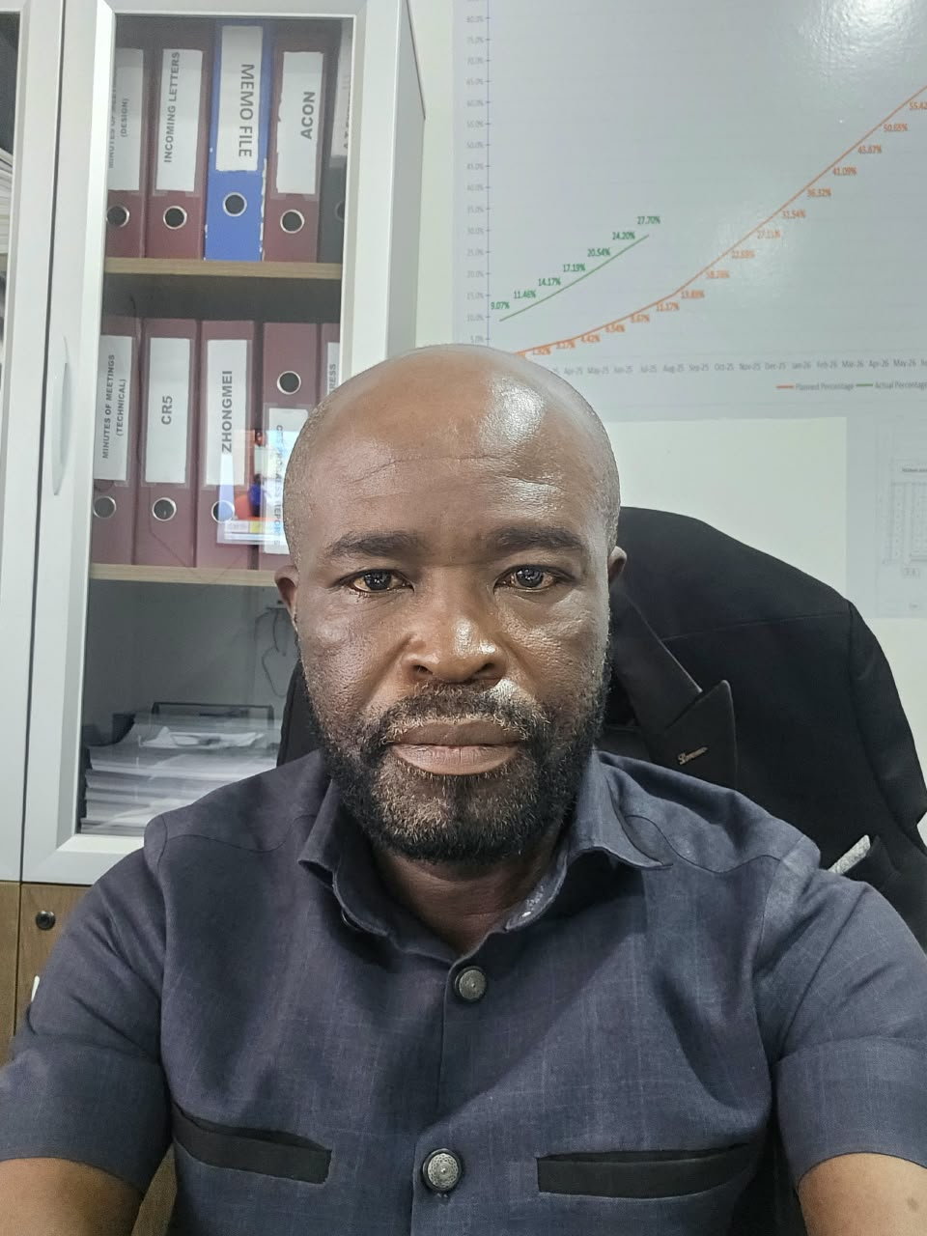t

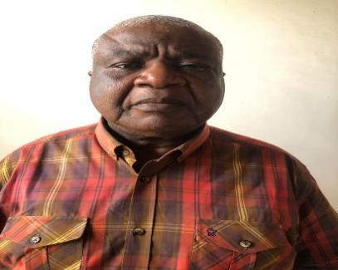

Field of competence summary
- Environmental, Social and Health Impact Assessment (ESHA)
- Environmental and Social Management Plans (ESMP)
- Environmental and Social Impact Assessment (ESIA)
- Environmental and Social Due Diligence (ESDD)
- Environmental and Social Action Plan (ESAP)
- Climate Change Adaptation to Infrastructure Sustainability (CCAIS)
- Environmental Resources Management (ERM)
- Health and Safety Plans (HSP)
- Traffic Management Plans (TMP)
- Public Consultation and Information Disclosure (PCID)
- Capacity Building and Training

